**CASE STUDY - 1**

**PRODUCTS**

**Product Details:**

db.store.insertMany([

{

"id": "1",

"product_name": "Intelligent Fresh Chips",

"product_price": 655.00,

"product_material": "Concrete",

"product_color": "mint green"

},

{

"id": "2",

"product_name": "Practical Fresh Sausages",

"product_price": 911.0,

"product_material": "Cotton",

"product_color": "indigo"

},

{

"id": "3",

"product_name": "Refined Steel Car",

"product_price": 690.00,

"product_material": "Rubber",

"product_color": "gold"

},

{

"id": "4",

"product_name": "Gorgeous Plastic Pants",

"product_price": 492.00,

"product_material": "Soft",

"product_color": "plum"

},

{

"id": "5",

"product_name": "Sleek Cotton Chair",

"product_price": 33.00,

"product_material": "Fresh",

"product_color": "black"

},

{

"id": "6",

"product_name": "Awesome Wooden Towels",

"product_price": 474.00,

"product_material": "Plastic",

"product_color": "orange"

},

{

"id": "7",

"product_name": "Practical Soft Shoes",

"product_price": 500.00,

"product_material": "Rubber",

"product_color": "pink"

},

{

"id": "8",

"product_name": "Incredible Steel Hat",

"product_price": 78.00,

"product_material": "Rubber",

"product_color": "violet"

},

{

"id": "9",

"product_name": "Awesome Wooden Ball",

"product_price": 28.00,

"product_material": "Soft",

"product_color": "azure"

},

{

"id": "10",

"product_name": "Generic Wooden Pizza",

"product_price": 84.00,

"product_material": "Frozen",

"product_color": "indigo"

},

{

"id": "11",

"product_name": "Unbranded Wooden Cheese",

"product_price":26.00,

"product_material": "Soft",

"product_color": "black"

},

{

"id": "12",

"product_name": "Unbranded Plastic Salad",

"product_price": 89.00,

"product_material": "Wooden",

"product_color": "pink"

},

{

"id": "13",

"product_name": "Gorgeous Cotton Keyboard",

"product_price": 37.00,

"product_material": "Concrete",

"product_color": "sky blue"

},

{

"id": "14",

"product_name": "Incredible Steel Shirt",

"product_price": 54.00,

"product_material": "Metal",

"product_color": "white"

},

{

"id": "15",

"product_name": "Ergonomic Cotton Hat",

"product_price": 43.00,

"product_material": "Rubber",

"product_color": "mint green"

},

{

"id": "16",

"product_name": "Small Soft Chair",

"product_price": 47.00,

"product_material": "Cotton",

"product_color": "teal"

},

{

"id": "17",

"product_name": "Incredible Metal Car",

"product_price":36.00,

"product_material": "Fresh",

"product_color": "indigo"

},

{

"id": "18",

"product_name": "Licensed Plastic Bacon",

"product_price":88.00,

"product_material": "Steel",

"product_color": "yellow"

},

{

"id": "19",

"product_name": "Intelligent Cotton Chips",

"product_price": 46.00,

"product_material": "Soft",

"product_color": "azure"

},

{

"id": "20",

"product_name": "Handcrafted Wooden Bacon",

"product_price": 36.00,

"product_material": "Concrete",

"product_color": "lime"

},

{

"id": "21",

"product_name": "Unbranded Granite Chicken",

"product_price": 90.00,

"product_material": "Metal",

"product_color": "gold"

},

{

"id": "22",

"product_name": "Ergonomic Soft Hat",

"product_price": 99.00,

"product_material": "Rubber",

"product_color": "black"

},

{

"id": "23",

"product_name": "Intelligent Steel Pizza",

"product_price": 95.00,

"product_material": "Cotton",

"product_color": "azure"

},

{

"id": "24",

"product_name": "Tasty Rubber Cheese",

"product_price":47.00,

"product_material": "Frozen",

"product_color": "orchid"

},

{

"id": "25",

"product_name": "Licensed Steel Car",

"product_price":20.00,

"product_material": "Cotton",

"product_color": "indigo"

}

])

**Product Queries:**

**Questions:**

1. Find all the information about each product

db.store.find({})

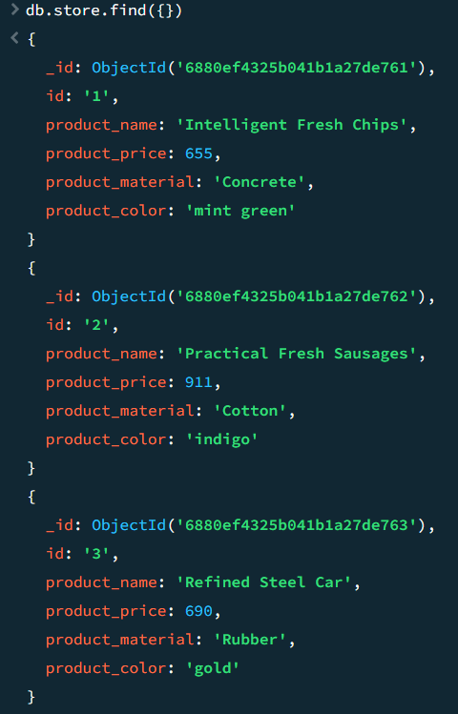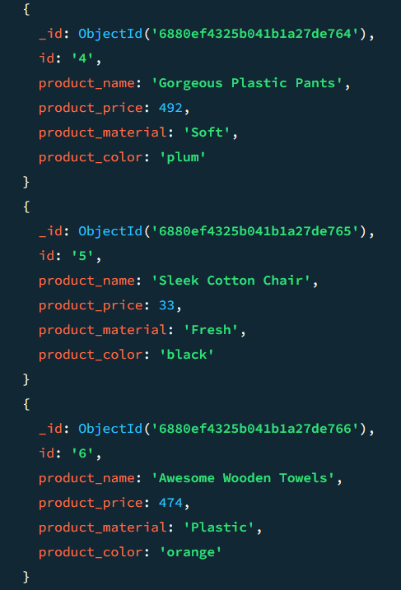

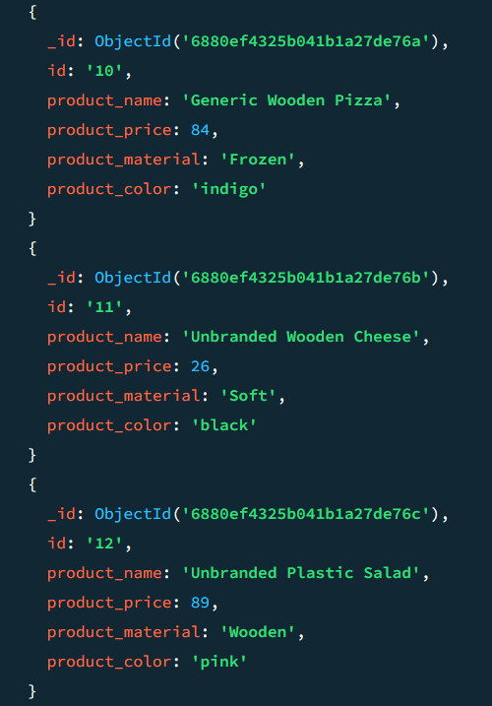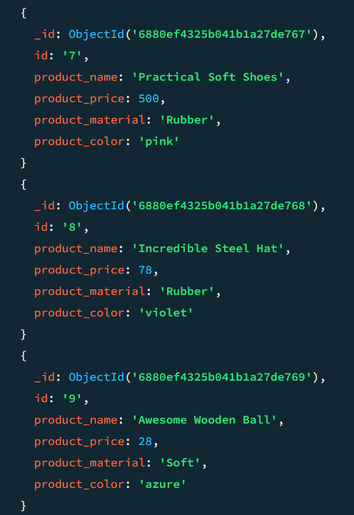

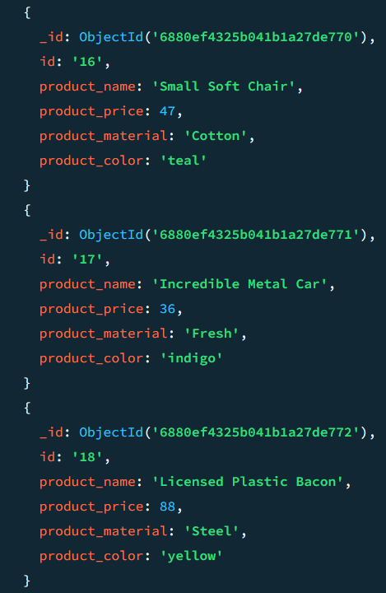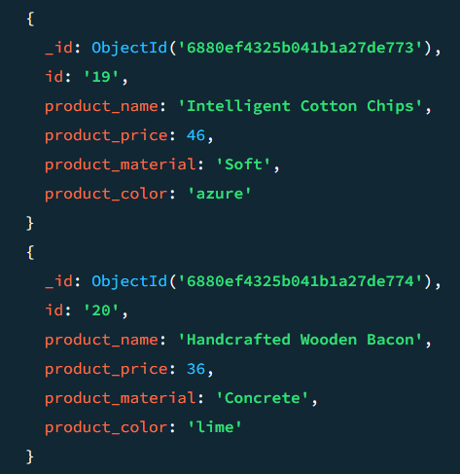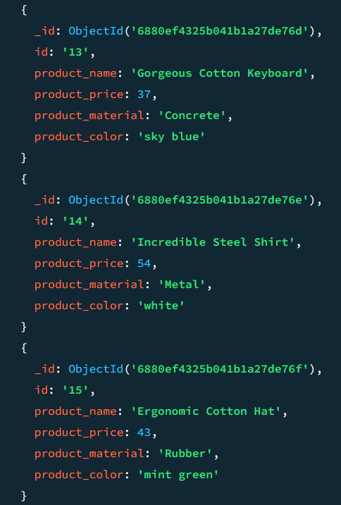

1. Find the product price which are between 400 to 800

db.store.find({product_price: {$gte: 400, $lte:800}})

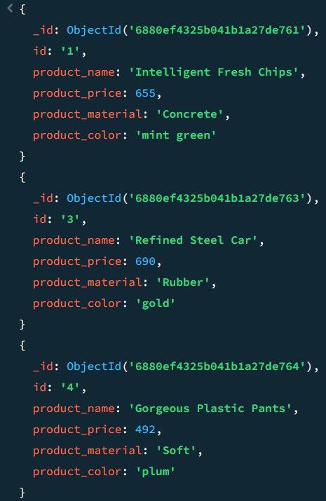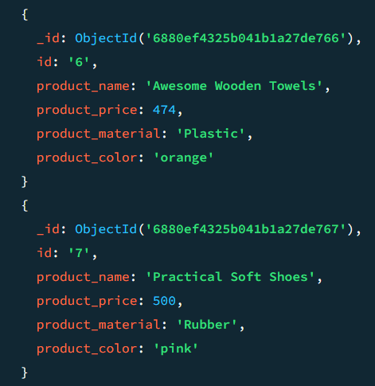

1. Find the product price which are not between 400 to 600

db.store.find({ $or: [{ product_price: { $lt: 400 } }, { product_price: { $gt: 600 } } })

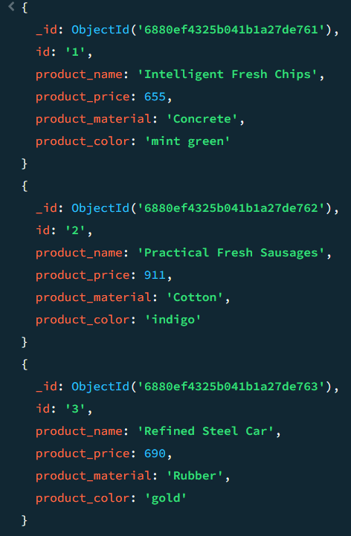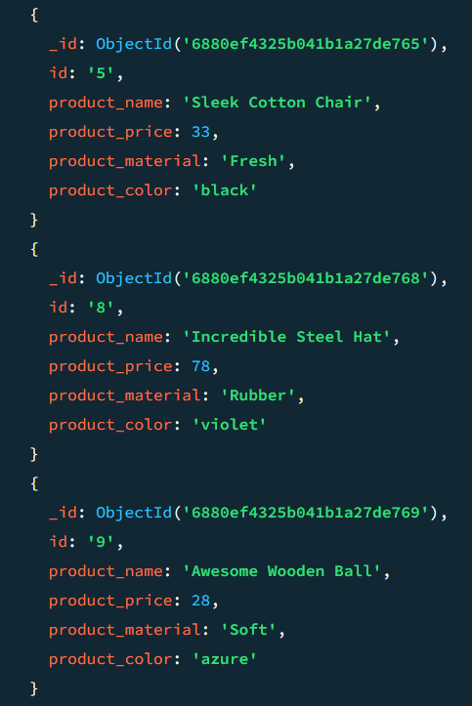

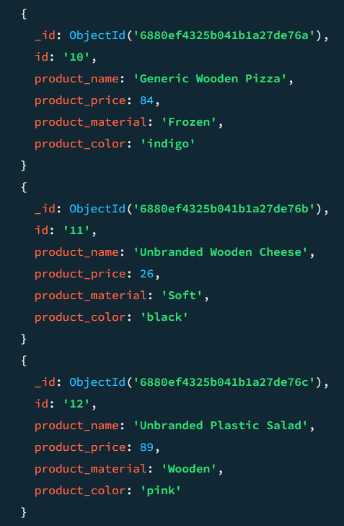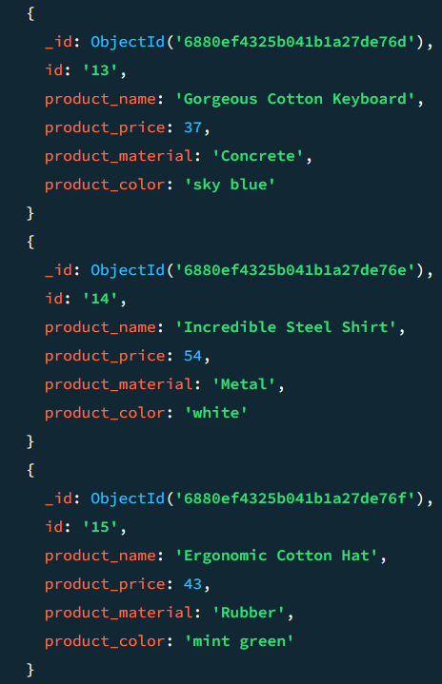

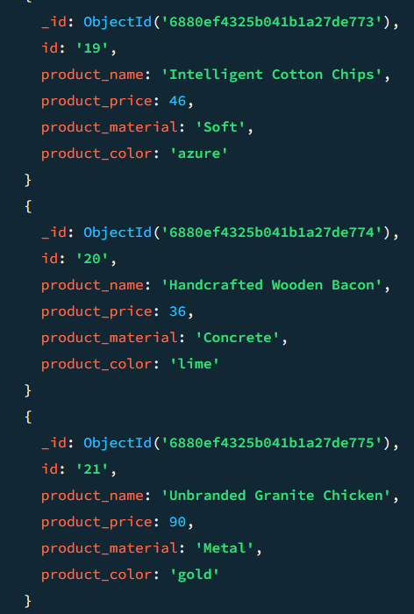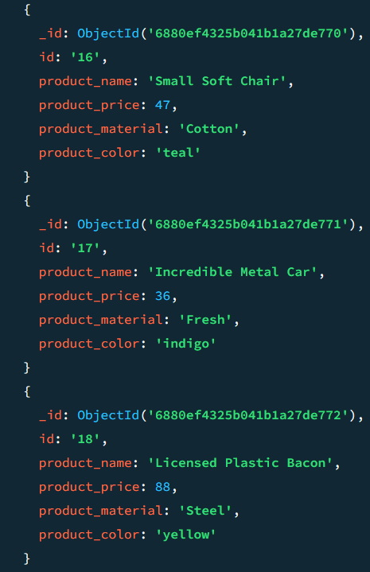

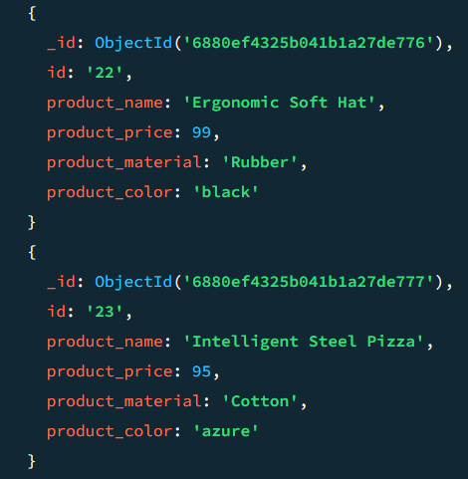

1. List the four products which are greater than 500 in price

db.store.find({product_price: {$gt: 500}}).limit(4)

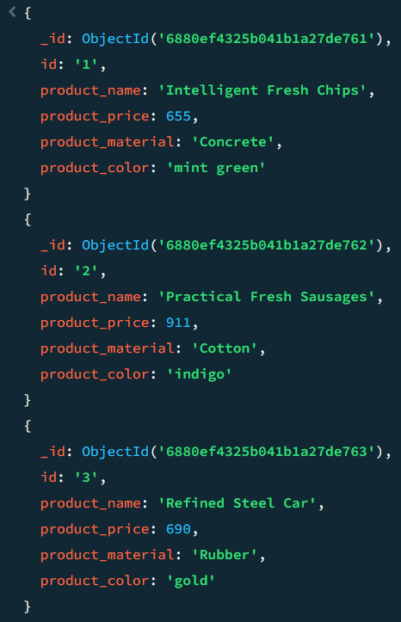

1. Find the product name and product material of each product

db.store.find({}, {product_name: 1, product_price: 1, _id: 0})

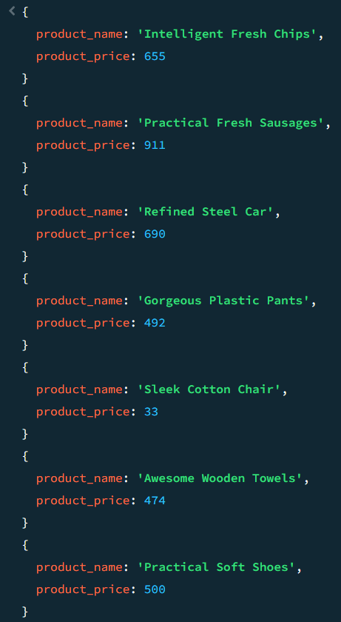

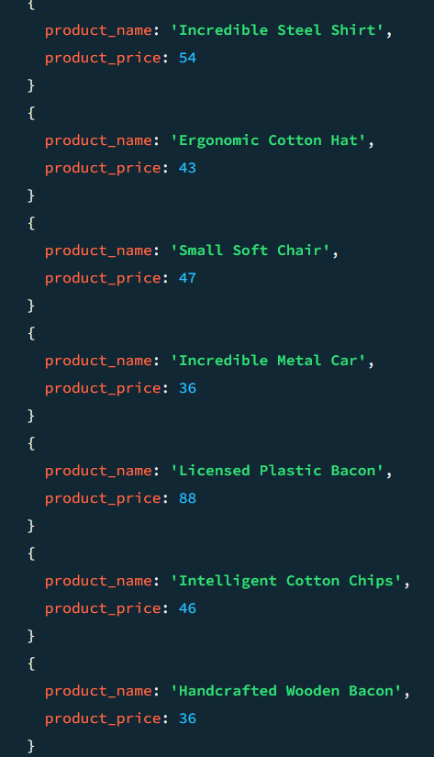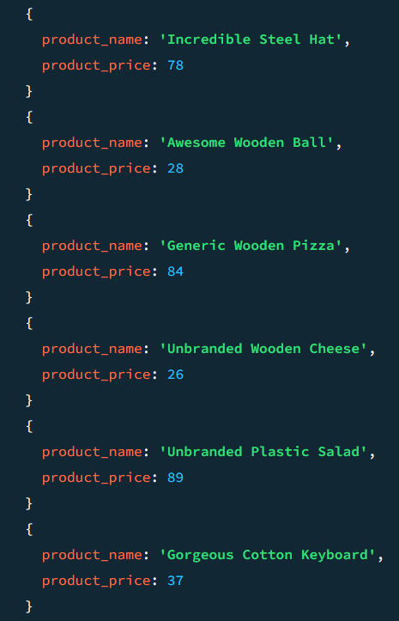

1. Find the product with a row id of 10

db.store.find({id: "10"})

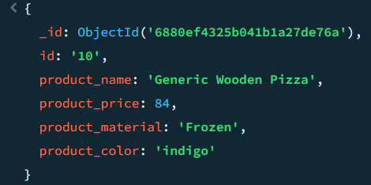

1. Find only the product name and product material

db.store.find({id: "10"}, {id: 1, product_name: 1, product_price: 1 })

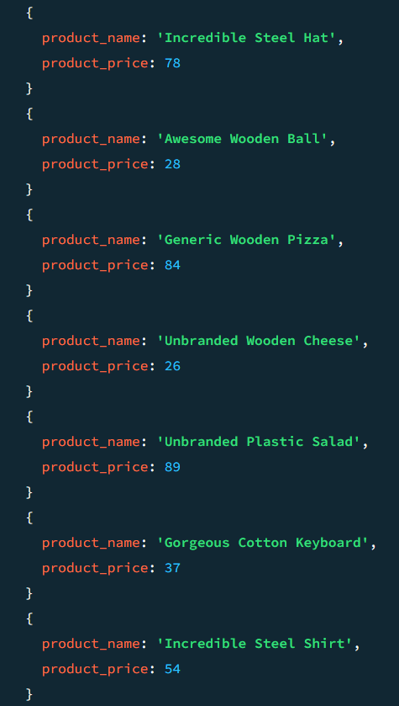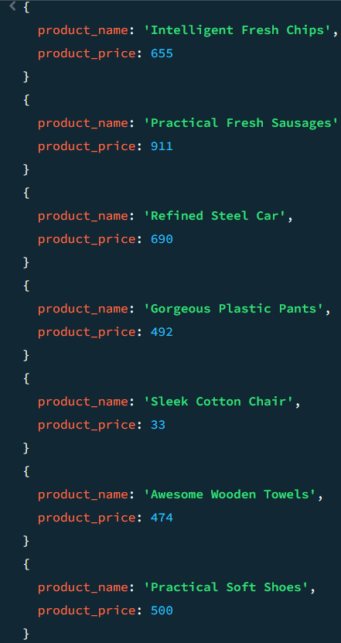

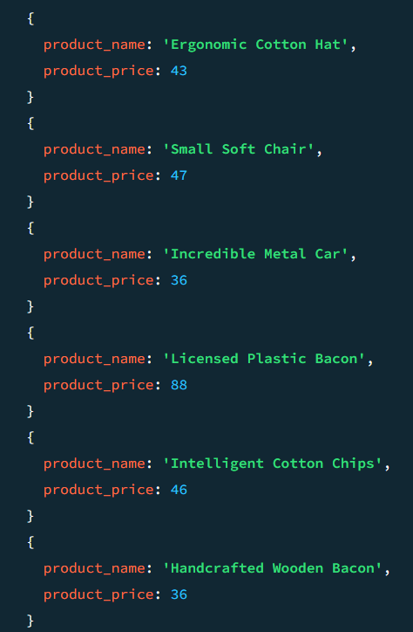

1. Find all products which contain the value of ‘soft’ in product material

db.store.find({product_material: /soft/i})

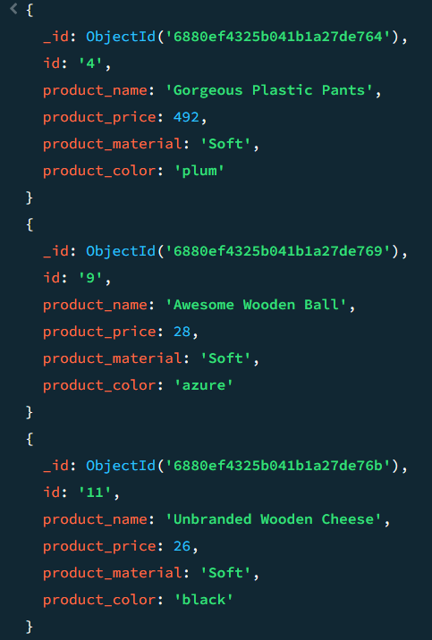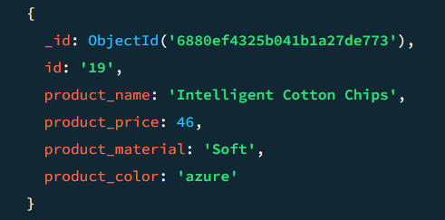

1. Find products which contain product color ‘indigo’ and product price ‘492.00’

db.store.find({product_color: "indigo", product_price: 492.00})

